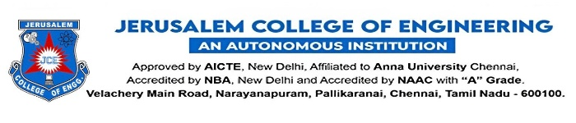
DEPARTMENT OF ARTIFICIAL INTELLIGENCE AND MACHINE LEARNING

S.No | Name of the Alumni | Contact Number | Linkedin ID | Designation | Place of Work
 | Mr. Lokesh Rao N | +919841208412 | https://www.linkedin.com/in/lokesh-rao-n-93615993 | Lead Product Engineer | AnviSoft Solutions,  Midrand, Gauteng, SA.
 | Dr. Nandha Kumar K G | +919840673530 | https://www.linkedin.com/in/dr-nandha-kumar-k-g-29748a202/ | Associate Professor | Amity University
 | Mr. Viyanney Maria Joseph | +918939672655 | https://www.linkedin.com/in/viyanney-maria-joseph | Full Stack Developer | Stridemex (OPC) Private Limited
 | Ms. Vasumathi Kachi Kidambi | +919790811910 | linkedin.com/in/vasumathi-kachi-kidambi-424512211 | DevOps Engineer | Zeb
 | Ms. Mohana Priya | +917418169699 | - | Senior Associative | Data Terrain India Pvt Ltd

